Sean Hand
Bellarmine University
DS-160
04/22/25

Where’s My Dinner EDA Report

Abstract

This project explores a food delivery dataset to predict delivery time and whether an order will be late using both linear and logistic regression. The dataset includes 884 rows with categorical and numerical features such as traffic, vehicle type, and weather. After encoding categorical variables and selecting a lateness threshold of 56.43 minutes, a logistic regression model achieved an accuracy of 89.8%, precision of 82.9%, and AUC of 0.95. The linear model, predicting continuous delivery time, achieved an R² of 0.83 and RMSE of approximately 8.27 minutes. These results suggest our models can accurately predict both lateness and duration, although model effectiveness depends on geography.
My project investigates delivery data with the goal of predicting whether a food delivery will be late and how long it will take. Two modeling strategies are used: logistic regression for binary classification (late/on-time) and linear regression for continuous prediction of delivery time. The classification target is whether the delivery will be late based on a threshold of 56.43 minutes (the average delivery time).
Timeliness is crucial in food delivery services. Companies like Uber Eats and DoorDash rely on accurately estimating delivery times to ensure customer satisfaction and optimize resource allocation. This dataset simulates real-world delivery data including distance, traffic, weather, courier experience, and time of day. The goal is to uncover which factors most affect delivery time and whether an order will be late.
The dataset contained 884 rows and 9 columns after dropping any row containing a null value. However, after one-hot encoding for linear regression purposes, the column count increased to 20. This allowed for usage of features such as weather in determining if an order would be late or not. Here’s a sample of our data before encoding:

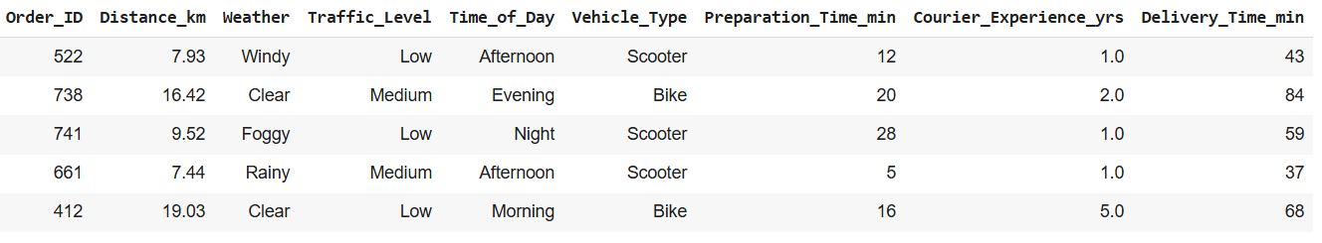
Here’s our columns after encoding:

To prepare the data was clean it by dropping 48 rows the first thing I did was get the average delivery time for an order. The reason for this was to do our logistic model we needed some metric in which to base whether an order was late or not. Next, I created various visualizations to see what the distribution of the data set was. Then I encoded the features that were categorical so they could be used in a linear model.
Below is a sample of data collected using random feature selection and training/testing parameters:
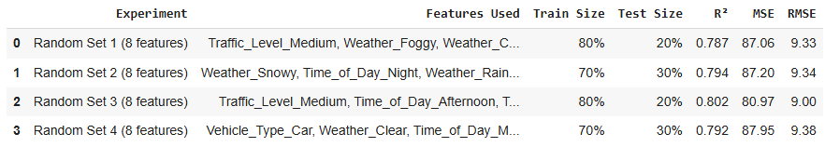
I used Python with google collab while doing this project. Here is a list of all the libraries I imported during this project: Pandas, Seaborn, Matplotlib, Numpy, IPython, and Sklearn.
While at the end I used random samples of features and testing/training sizes, my main project focused on linear and logistic models that used all features. The results I got for linear regression are:
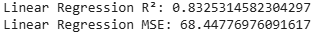
And for logistic regression:
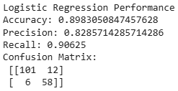
Here are a few visualizations taken from both the linear and logistic model:
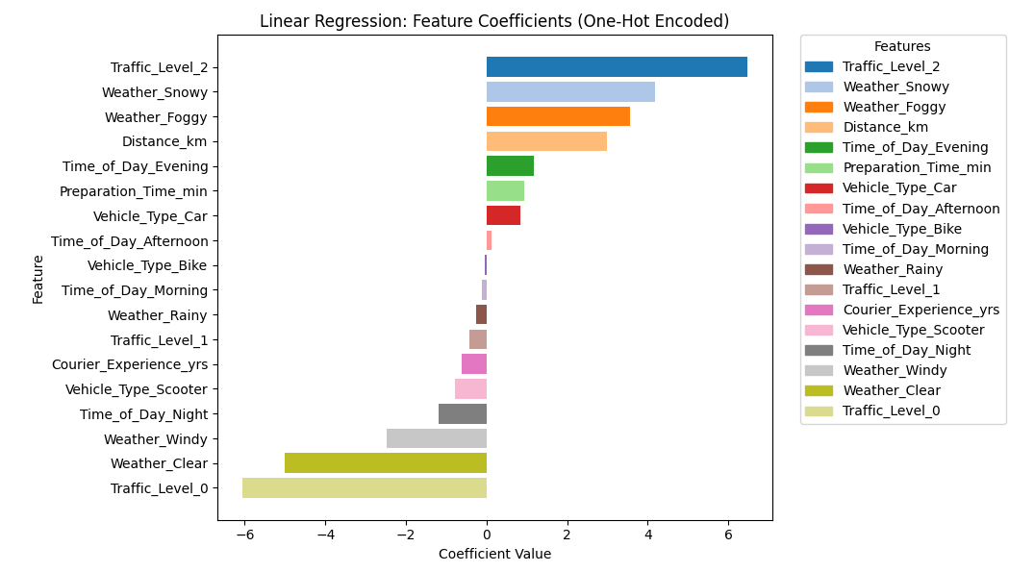
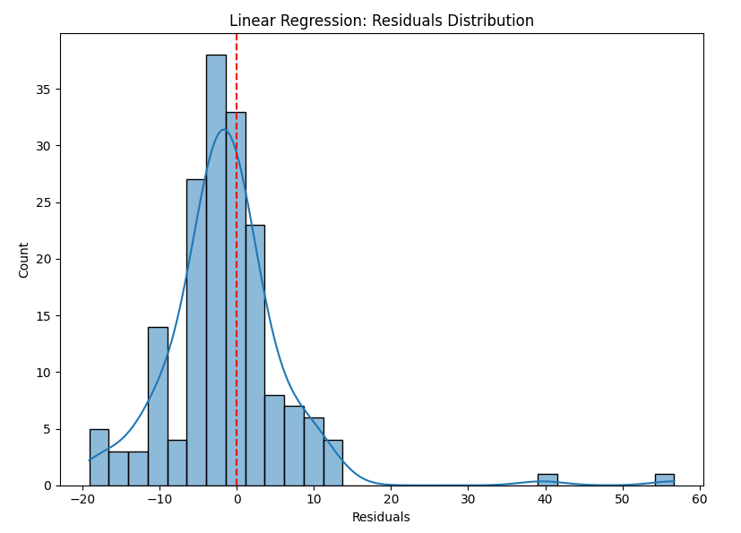
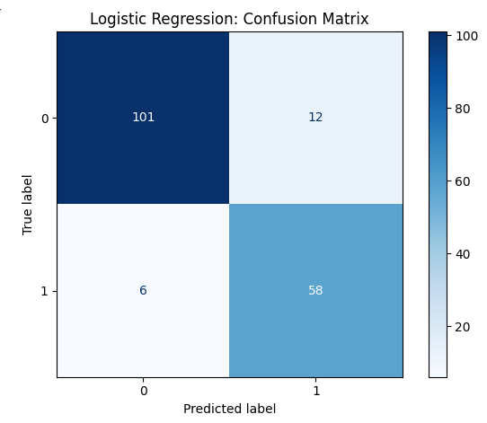
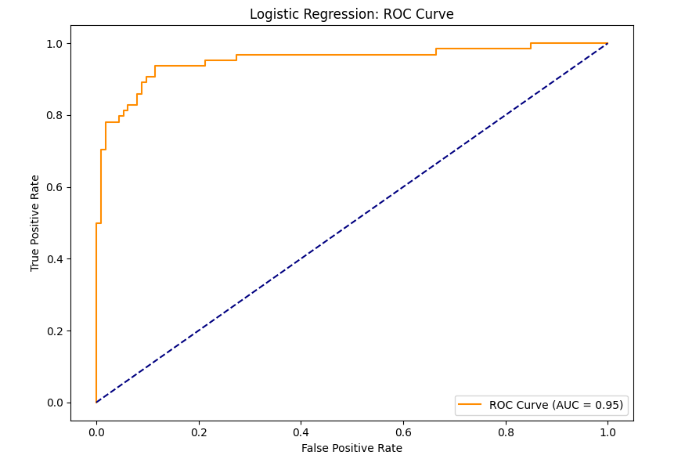
Overall, I’m pretty satisfied with the scores I got from both linear and logistic regression. Everything is above at least 80, meaning it’s performing quite well, and the 8.27 minutes RSME is pretty good in regard to real time data.
To note, there were only really two big issues with the data set, one which presented itself early, the other I noticed at the end. To start with, the data set is kind of small. After cleaning only 844 rows were left. Ideally, I would have liked a data set of around 5000 data to accurately build models. However, if the data was given, I was able to make pretty good models. Finally, the biggest issue is this data may not perform the same depending on which city you live in. To me, based on the fact that traffic levels had the biggest effect on the linear model, this data was recorded in a heavily populated city. If you tried to take data from a low populated area and add it into the dataset, it would likely just skew the data.
As mentioned, the models both performed successfully, and resulted in high scores all across the board. This includes good accuracy, and low errors which make both of them practical for real-world use. This could however change with an increase in data, but I predict that it would only make the models perform better. The key issue, however, as mentioned above, is these models must be restricted to a populated area. Still, as food delivery services such as uber eats, and grub-hub function more so inside cities this shouldn’t be too big of a problem.

